
restaurent MANAGEMENT SYSTEM
Oop project


BS Computer Science
Section: B

Introduction
The Restaurant Management System is a comprehensive software solution designed to streamline and enhance the operational efficiency of a restaurant. Implemented in C++, this system leverages object-oriented programming principles to manage various aspects of restaurant operations, including menu management, order processing, table management, and user roles.
This system provides a user-friendly interface for different types of users, such as Administrators, Waiters, and Customers, allowing each role to perform specific tasks relevant to their responsibilities. The Administrators can manage the menu, view tables and earnings, while Waiters can take orders, print bills, and manage tables. Customers can reserve tables, place dine-in orders, and create takeaway orders.
Key functionalities of the system include:
- Menu Management:
Allows the addition, display, and persistence of menu items.
- Order Processing:
Facilitates the creation and management of orders, including calculating total bills.
- Table Management:
Manages the status of tables, including occupancy and reservations.
- User Authentication:
Ensures secure access for different user roles, with each role
having specific permissions and functionalities.
- File Operations:
Supports saving and loading menu data to and from files,
ensuring data persistence.

Explanation:
- User Authentication

- User Login:
  - The system will prompt the user to enter their credentials.
  - Based on the entered username and password, the system will authenticate and assign a role (Administrator, Waiter, Customer).
- Role-Based Functions

Administrator Functions
- Manage Menu:
  - Add New Items: Input item details (name, price, etc.) to add to the menu.
  - Display Menu: View the current menu with all items listed.
  - Save Menu: Save the current menu to a file for persistence.
  - Load Menu: Load the menu from a file to restore previous items.
- View Tables:
  - Display the status of all tables (occupied, reserved, available).
  - View Earnings: Check the total earnings based on completed orders.
- Waiter Functions
Take Orders:
  - Select a Table: Choose the table number for which the order is being taken.
  - Add Items: Add selected items from the menu to the order.
  - Calculate Total: The system will automatically compute the total bill.
  - Print Bill: Generate a bill for the customer.
Manage Tables:
  - Change Table Status: Mark tables as occupied, reserved, or available.
  - View Current Orders: See the current orders associated with each table.

- Customer Functions
Reserve Table:
  - Input Details: Provide necessary details to reserve a table.
  - Confirm Reservation: The system confirms and updates the table status.
Dine-In Order:
  - Select Items: Choose items from the menu.
  - Place Order: Submit the order for processing by the wait staff.
Takeaway Order:
  - Select Items: Choose items for takeaway.
  - Confirm Order: Finalize the order and provide any necessary details for pickup.
- File Operations
Saving Data:
  - Menu items and orders can be saved to files to ensure data persistence.
  - Use appropriate file handling functions to write data to files.
Loading Data:
  - Previously saved menu items and orders can be loaded from files to restore the system state.
  - Use appropriate file handling functions to read data from files.
- System Maintenance
Adding Features:
  - The modular design allows for easy addition of new features.
  - Modify or extend existing classes and methods as needed.
Bug Fixes:
  - Regularly test the system for any issues.
  - Debug and fix any problems that arise to ensure smooth operation.

- Exiting the System
Save Current State:
Ensure all necessary data is saved before exiting.
Logout:
The user logs out, and the system returns to the initial state ready for the
next login.
- Code Structure Overview
Classes:
  - User: Base class for handling user details and authentication.
  - Administrator: Derived classes for specific user role.
  - Waiter: Derived classes for specific user role.
  - Customer: Derived classes for specific user role.
  - MenuItem: Represents individual menu items.
  - Menu: Manages the list of menu items.
  - Table: Manages table status and associated orders.
  - Order: Handles order details and bill calculation.
Functions:
  - User-related functions for login and role management.
  - Menu-related functions for adding, displaying, saving, and loading items.
  - Table-related functions for managing reservations and statuses.
  - Order-related functions for creating, viewing, and processing orders.
  - File handling functions for saving and loading data.

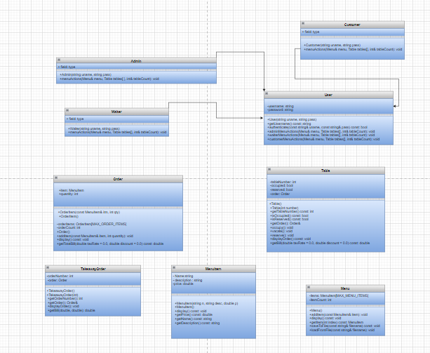
- UNIFIED MODEL LANGUAGE DIAGHRAMME:

- CONTRIBUTION:

- Every team member has contributed a lot into it by not only contributing but also, by teaching other members about their logic in this project.

- We have contributed by assigning three classes each to everyone and discussing the int main () function one by one.

- Abdullah was assigned to classes as menu_item, table, waiter

- Daniel was assigned to classes as customer, menu, Take away

- Musa was assigned to classes order, user, admin

- CODE OUTPUT:

- Code starts with the logo of MAD RESTAURENT, and it happens to print`s:
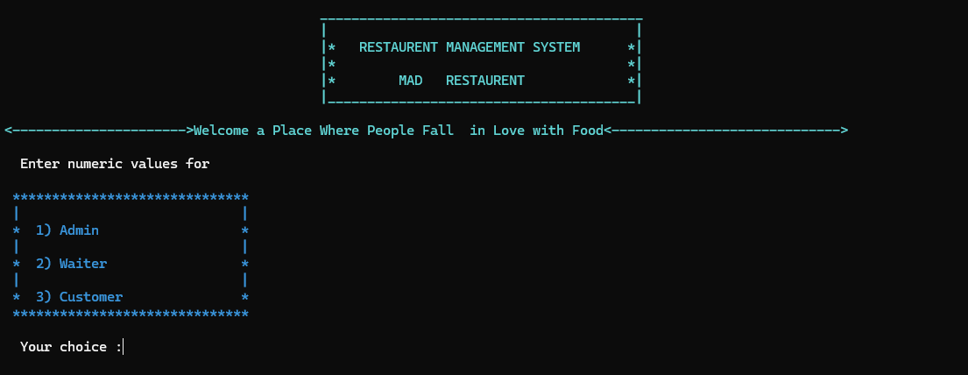
- You get to choose three option whether you are admin waiter or customer.

- Your choice is checked with numeric value assigned to the respective option

- If we choose the first option then it asks for username and password so we have

fixed the password as per admin and password as password:

- Now a hard code appears as to select the option for the admin to see

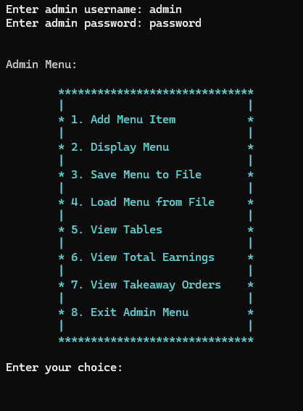
- If we press the first option, then:

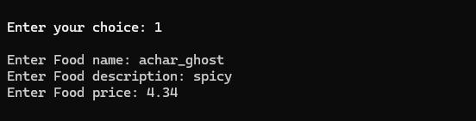

- Now if we display menu from the option 2

- It will print the menu with new values as achar_ghoust

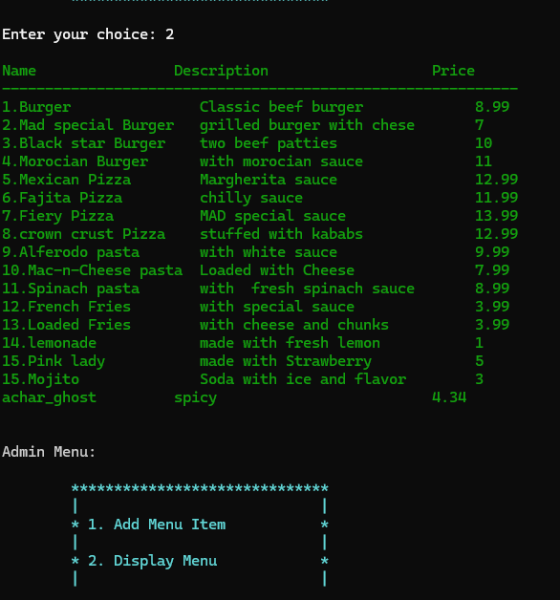

- And again displays admins options as by the do while loop

- Now if you wish to save file press option 3

- It will ask the name for the file

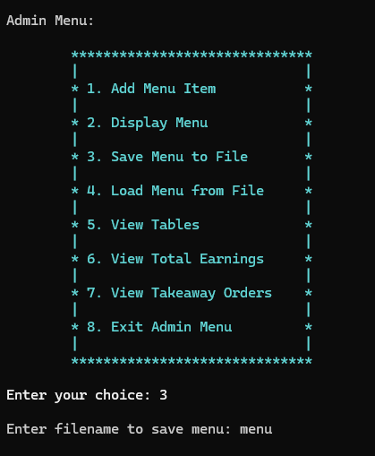

- And done

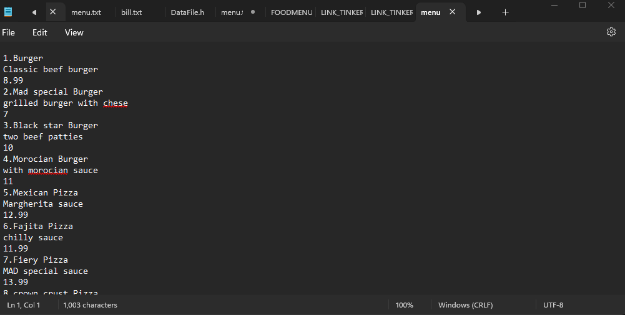

- Now for the option 5 you can view the tables

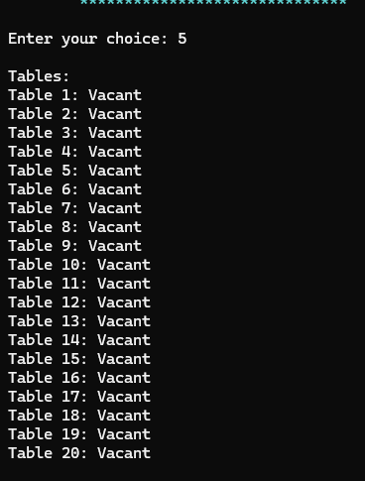

- Option 6 for total earning

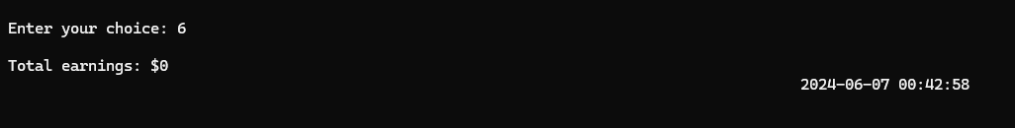

- Option 7 for take away orders count

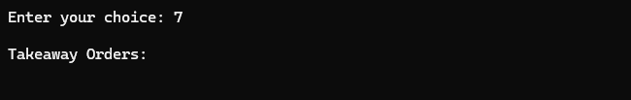

- Option 8 for existing loop of admin class

- Now the main loop of programs asks to continue or not
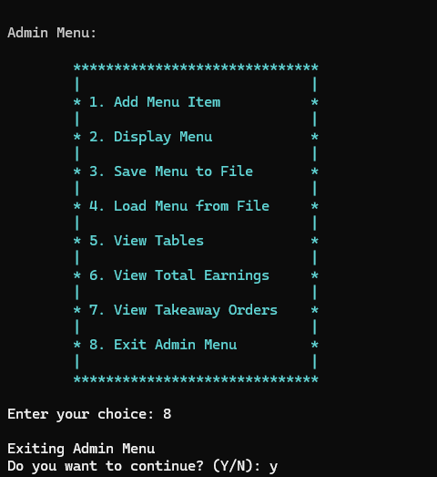

- Now if we use second option as waiter we press option 2
- A grid of waiter action options appear

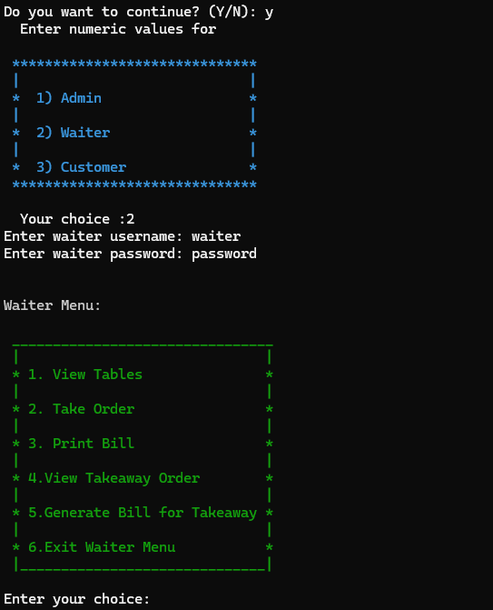

- If pressed option is 1 then

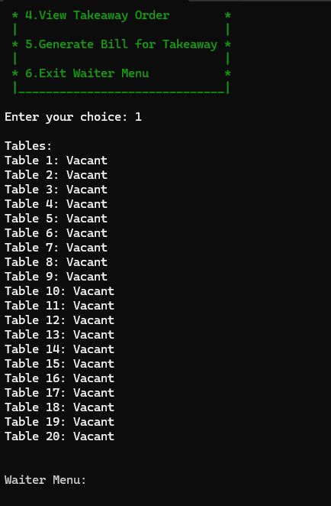

- If pressed option 2 it takes order but first asks table number since we did not reserved or dined in any customer so:

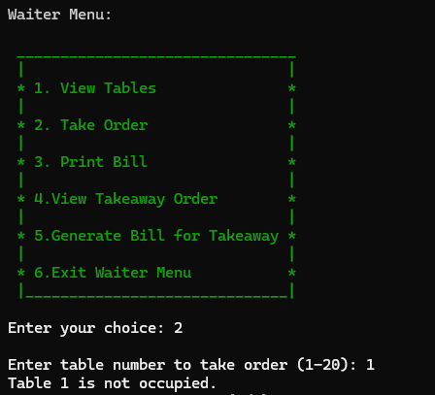

- Option 6 to exit the loop of class waiter

- Option 1 pressed for customer

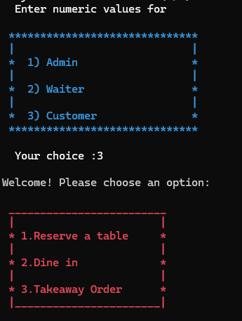

- If pressed 1

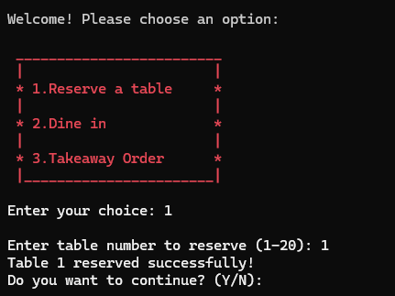

- If resevered, then

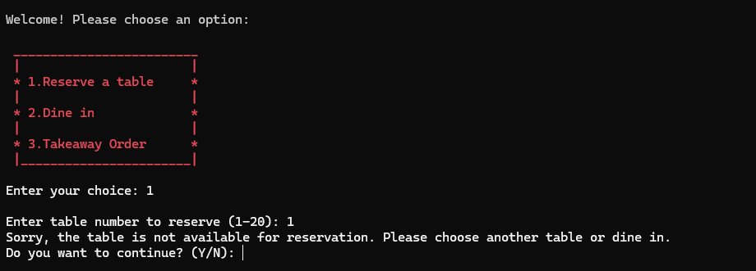

- If pressed 2 then

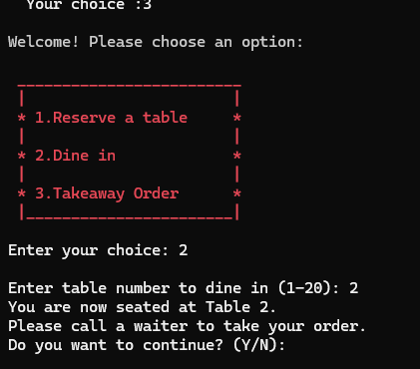

- If occupied then,

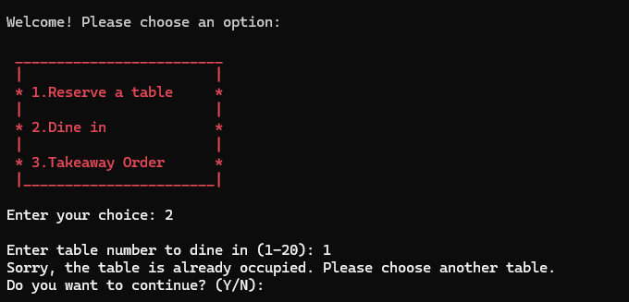

- 1f pressed 3 then it asks order number and then menu prints to take order directly

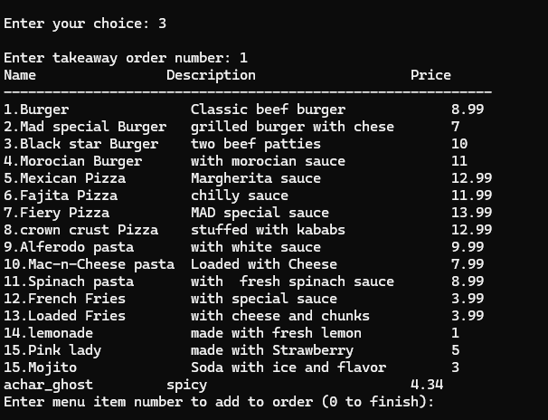

- 1 choose 22 burgers

- Now pressing zero to finish menu loop

- Now it asks to print bill via waiter

- So, we go into waiter by login then press 5 for genrating takeaway bill and then by entering order no we get bill

